Note: Dear instructor, the program was not accepting wire 1-14 and somehow it did not label GND.
(I have no idea what does Vcc and GND mean.)
Also the drawing in lab manual was obscure so here are my results.

Operation of AND gate and its truth table

A1/A2/A3/A4 | B1/B2/B3/B4 | Y1/Y2/Y3/Y4
0 | 0 | 0
0 | 1 | 0
1 | 0 | 0
1 | 1 | 1

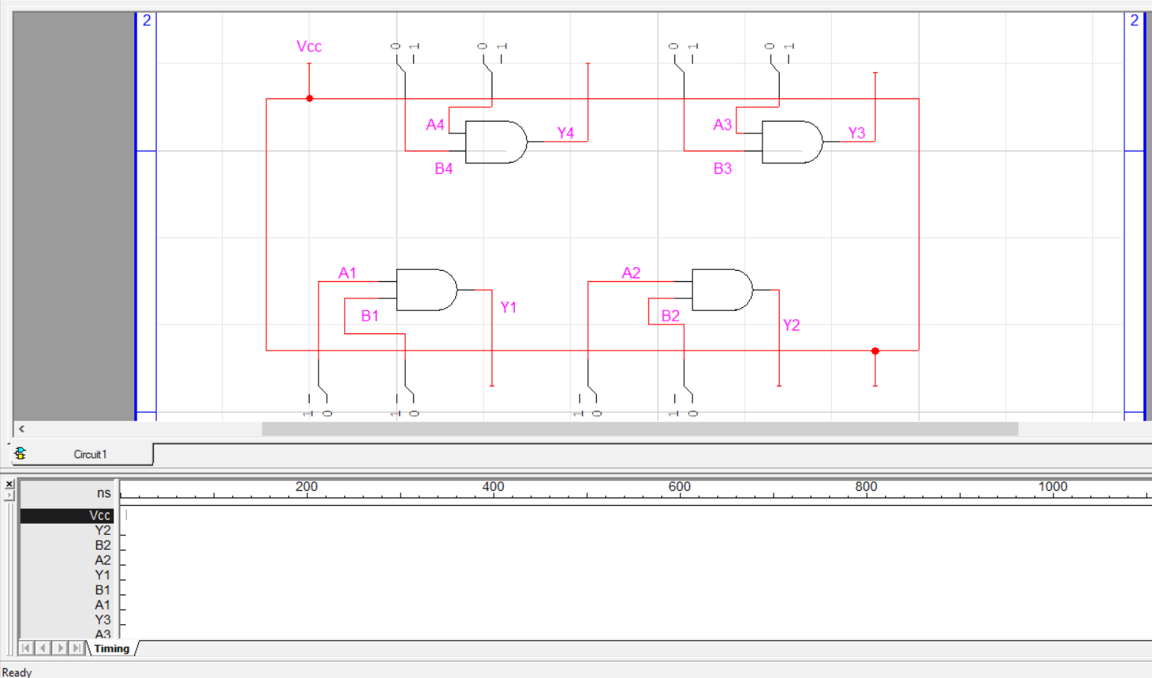

Operation of OR gate and its truth table

A1/A2/A3/A4 | B1/B2/B3/B4 | Y1/Y2/Y3/Y4
0 | 0 | 0
0 | 1 | 1
1 | 0 | 1
1 | 1 | 1
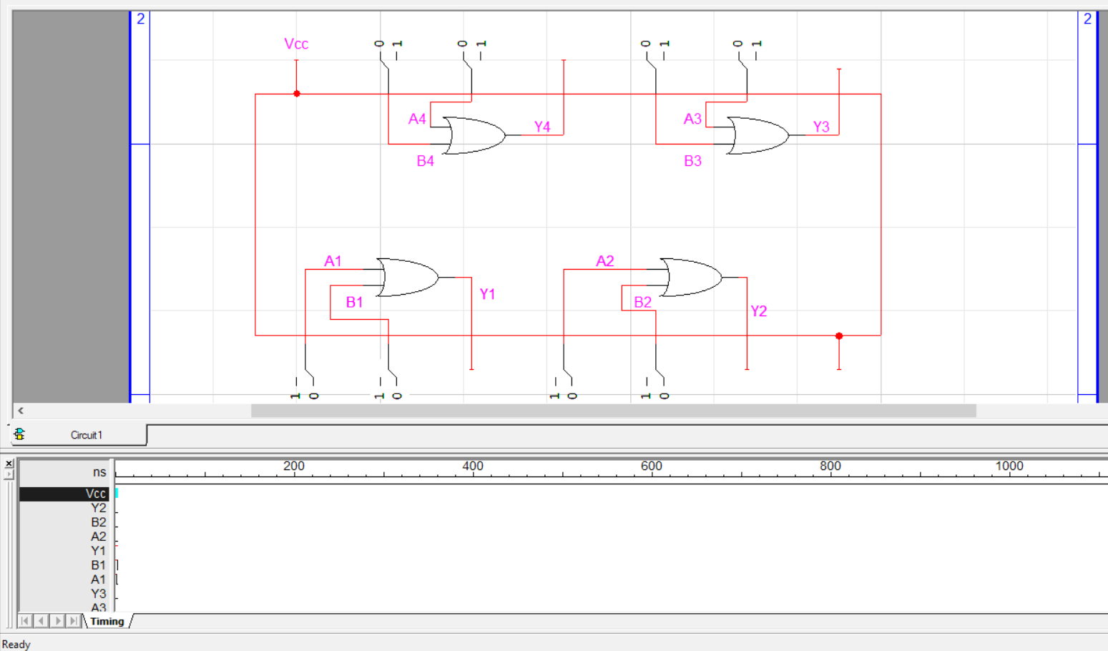
Operation of NOT gate and its truth table

A1/A2/A3/A4/A5/A6 | Y1/Y2/Y3/Y4/Y5/Y6
0 | 1
1 | 0
